Alphasense fan experiment

MJC

Contents

26-July-2017 - Sunon Fan test 1 1

Notes 1

Test 1 1

Test 2 2

Test 3 4

# 26-July-2017 - Sunon Fan test 1

## Notes

* Testing Sunon 60 mm fan
* Set two Alphasenses side by side one with Kyles external fan attached, Alphasense fan still attached and running on both.

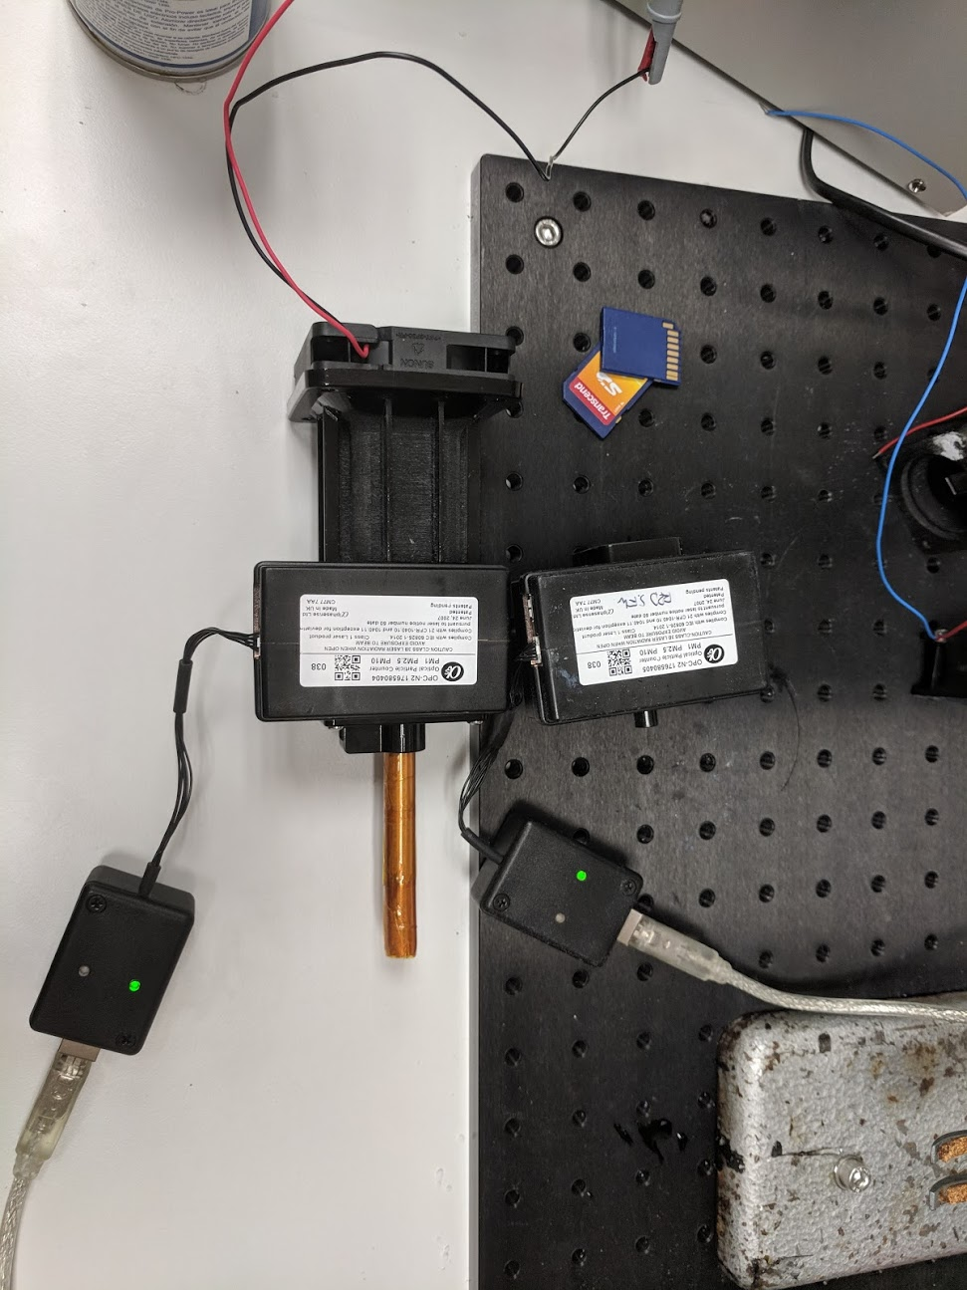

## Test 1

* Both Alphasense units powered up
* Increasing fan voltage in increments of 0.25 V every 10 loops
* Holding voltage at max (10 V) once its reached
* Filename *AlphasenseData_26072018_1.csv*
* 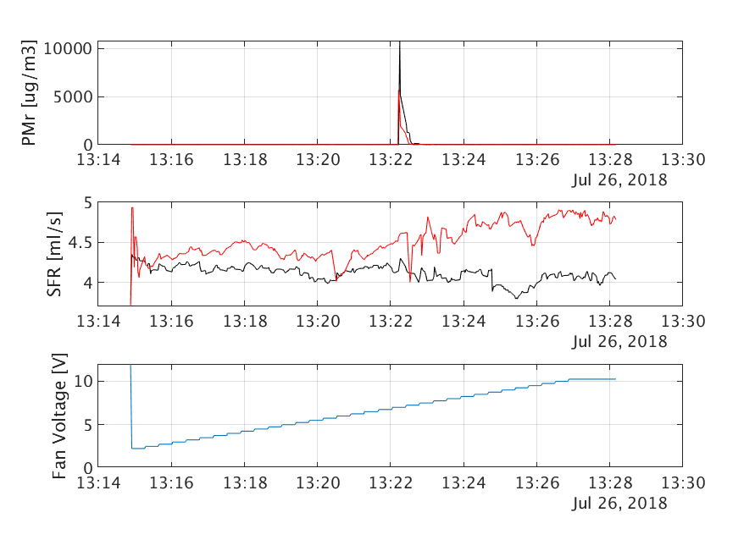Rolling average with 20 point window

## Test 2

* Made the unit so that the fan resets back to zero and ramps again
* Filename *AlphasenseData_26072018_2.csv*
  + 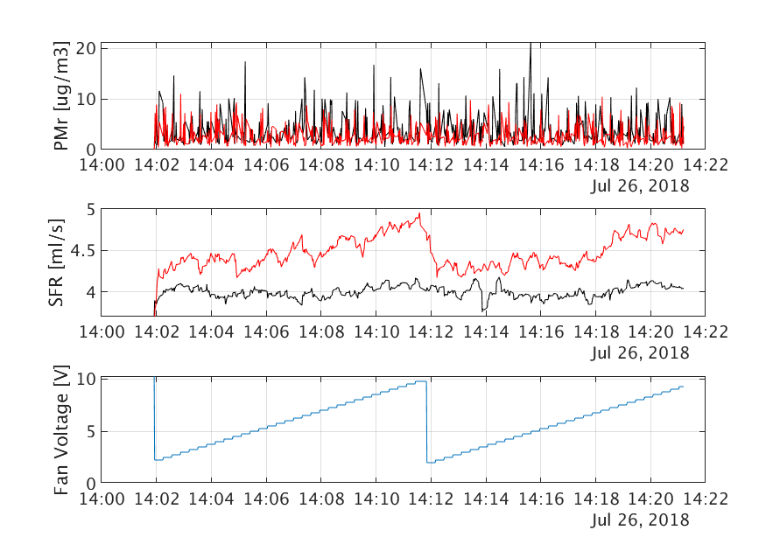Added a rolling average over the Pmr window is 20 points

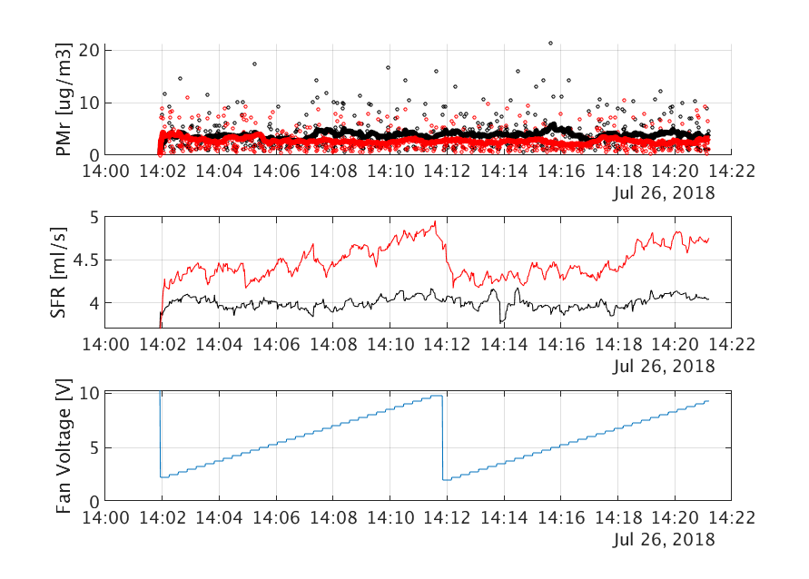

## Test 3

* Decided to increase the wait time at each voltage step.
* Test crashed

